1. Go to: <https://github.com/totorotoby/FishRand>
2. Download the directory as a ZIP.

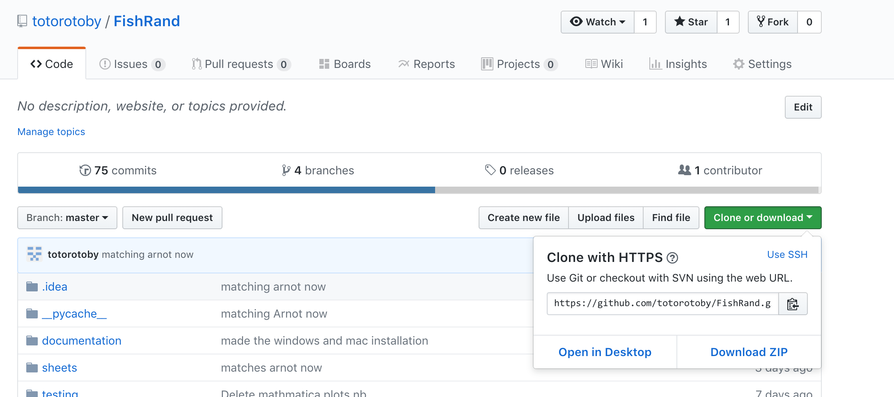

1. Unzip, on your computer and check the documentation sub directory for instillation and running instructions.
2. If FishRand is updated, there are two ways of getting the updated version.
3. Follow the previous instructions and discard your old FishRand folder.
4. Cd in the command prompt or terminal into the FishRand directory and run the command: “git pull”, to update the directory to the newest version. (In the below picture nothing has been updated, but if there is an update a few messages about the update will appear).

